*Knowledge* *&* *Technology*

**BangladeshArmy** **University** **of** **Engineering** **&** **Technology**



Department of Computer Science & Engineering

A project Report on

**Green Life**

A project is submitted in partial fulfillment for the requirements of the degree of Bachelor of

Science in Computer Science and Engineering

Submitted by Submitted to

Tanvir Ahmed Md. Omar Faruq

ID No.: 19104012 Lecturer, Dept. Of CSE, BAUET

Naima Mannan Mumu Mst Irin Suntana

ID No.: 19104042 Lecturer, Dept. Of CSE, BAUET

Department of Computer Science and Engineering

Bangladesh Army University of Engineering and Technology

October,2022

**Abstract**

Web based projects are projects/application which are deployed on world wide web(Internet) and these type of projects can be accessed by any device, any location .You just need internet and browser . Our project is a web based yoga, exercise and health tips platform . We have used programming and scripting language like PHP, JavaScript, HTML,CSS. User can use our platform to see our plan ,trainer list,our product, buy product,,information of health tips.

**List of contents**

**Chapter Title Page No**

Abstract 1

1 Introduction 5-7

* 1. Introduction 5
  2. Objectives 5-6
  3. Advantages 6
  4. Disadvantages 6
  5. Conclusion 7

2 Background Study 8-9

* 1. Introduction 8
  2. Existing Work 8
  3. Conclusion 9

3 Methodology 10-14

3.1 Introduction 10

3.2 Algorithm 10

3.3 Flowchart 11

3.4 Use Case Diagram 12

3.5 Entity Relationship(ER) Diagram 13

3.6 Conclusion 14

4 Result & Discussion 15-36

4.1 Introduction 15

4.2 Visual Representation Of The System 15

4.3 Discussion 36

4.4 Conclusion 36

5 Conclusion & Future Work 37

5.1 Introduction 37

5.2 Future Work 37

5.3 Conclusion 37

REFERENCES 38

**List of figures**

**Figure No Title Page No**

3.3.1 Flowchart 11

3.4.1 Use Case Diagram 12

3.5.1 Entity Relationship Diagram 13

4.2.1 Home Page 16

4.2.2 User Registration page 17

4.2.3 User Profile page 18

4.2.4 Update profile page 19

4.2.5 Log in page 20

4.2.6 Condition page-1 21

4.2.7 Condition page-2 22

4.2.8 Privacy of users 23

4.2.9 Anti_Hospitality page 24

4.2.10 Our plan 25

4.2.11 Advanced package 26

4.2.12 About page 27

4.2.13 Our Trainer 28

4.2.14 Youtube Channel 29

4.2.15 Log Out 30

4.2.16 Database Login Table 31

4.2.17 Information Table 31

4.2.18 user Table 32

4.2.19 Register Table 33

4.2.20 Package Table 34

4.2.21 Upload Table 35

**Chapter 1**

**Introduction**

* 1. **Introduction**

A Web application (Web app) is an [application program](https://www.techtarget.com/searchsoftwarequality/definition/application) that is stored on a remote server and delivered over the Internet through a browser interface. [Web services](https://www.techtarget.com/searchapparchitecture/definition/Web-services) are Web apps by definition and many, although not all, websites contain Web apps. According to Web.AppStorm editor Jarel Remick, any website component that performs some function for the user qualifies as a Web app.

Web applications can be designed for a wide variety of uses and can be used by anyone; from an organization to an individual for numerous reasons. Commonly used Web applications can include webmail, online calculators, or [e-commerce](https://www.techtarget.com/searchcio/definition/e-commerce) shops. Some Web apps can be only accessed by a specific browser; however, most are available no matter the browser.[1]

Web applications do not need to be downloaded since they are accessed through a network. Users can access a Web application through a web browser such as Google Chrome, Mozilla Firefox or Safari.

For a web app to operate, it needs a Web server, application server, and a database. Web servers manage the requests that come from a client, while the application server completes the requested task. A database can be used to store any needed information.

Web applications typically have short development cycles and can be made with small development teams. Most Web apps are written in [JavaScript](https://www.theserverside.com/definition/JavaScript), [HTML5](https://www.techtarget.com/whatis/definition/HTML5), or Cascading Style Sheets (CSS). Client-side programming typically utilizes these languages, which help build an applications [front-end](https://www.techtarget.com/whatis/definition/front-end). Server-side programming is done to create the [scripts](https://www.techtarget.com/whatis/definition/script) a Web app will use. Languages such as [Python](https://www.techtarget.com/whatis/definition/Python), Java, and [Ruby](https://www.techtarget.com/whatis/definition/Ruby) are commonly used in server-side programming.

* 1. **Objectives**

Web applications (or web apps) are programs on the internet that can be accessed in web browsers (Firefox, Chrome, Safari, IE, etc). These programs can provide any kind of functionality that you need to help your business or organization run more smoothly. Some examples of web apps are [product catalogs](http://www.canadiantire.ca/AST/browse/6/Tools.jsp?locale=en), [search engines](http://google.com/), [project management tools](http://www.pivotaltracker.com/), web mail, and the list goes on and on**.**

Web apps are very dynamic. They allow users to interact with your data to get the exact information they want. They are also very good at automating day-to-day tasks. Imagine a system that lists your inventory, shows related parts for a chosen item, and allows a user to order a part and have it shipped, all automatically. This site would automatically update for people as they used it – the number of parts in the system changes as the number of parts grows or shrinks. Keeping a static web site up-to-date with inventory, counts, orders, etc, would be so much work that it borders on impossible.

The key to a system like this is the database. A database is a place to keep your data, and is (usually) centrally accessed. This central access to data gives everyone the same view of the system (that there are no more replacement blades available, for example). Based on the data that is retrieved from the database, the web app chooses a course of action. By merging the dynamic abilities of the web app with the data storage/searching abilities of the database, you can create some very efficient and time-saving apps.[[4]](http://eveningdesign.com/blog/2012/08/the-purpose-of-a-website/)

* 1. **Advantages**
* **Runs on any OS**: It’s programmed to run on any OS . It must appropriately adapt to iOS, Android, and Windows Phone — amongst other operating systems.
* **Runs using easy URL:** These apps run on the device’s own browser through an easy URL.
* **Need not be downloaded:** They don’t got to be downloaded and installed from app stores like Google Play or Apple’s App Store. This translates into money-saving since having an immediate link through an internet app is free.
* **Need not be updated like apps:** They may also open websites. This suggests that they don’t require to be updated within the way common apps do.
* **Cost Efficient:** The most important benefit you’ll draw faraway from it’s its price. Web app development is that the cheaper quite app development. It consists of making a link or several links between the appliance and an URL. Developing a native app or an interpreted app entails a better cost but its chances to succeed are far greater.[3]
* **Always up to date:** They do not require to be updated often, in the way common apps usually do. It is the website/URL to which the application is directly linked that gets updated to its most recent version. And, as everyone accesses the same version of the web application via the same URL, all users use the most up-to-date & same version of it at all times.[2]
* **Client Secure Login :**  Impress clients with a modern web portal and improve customer service with automated processes.
* **Storage increase :**With the availability of the cloud, storage space is virtually infinite.[5]

* 1. **Disadvantages**
* **Creates problem if website is not responsive:** The website responsiveness means the website data displays on every platform and every size of screens correctly.
* If your website undergoes any quite issue, your application are going to be in trouble too. Don’t assume that your web app will work perfectly if you don’t have a top quality corporate website. For instance, if the web site’s URL takes a while to load or if uncomfortable ‘cookies’ show up when entering the website, accessing it through the appliance will entail an equivalent issues. The matter isn’t inherent to your web app. It’s rather located within the website’s development.
* **Internet connection is compulsory:**An Internet connection are going to be an absolute must run it. Otherwise, you’ll not be ready to browse the website.
* It will also lose visibility because it won’t get on display within the stores.
* In addition, there’ll be some access restrictions on certain hardware features of the device it’s running on.[3]
* **Restricted Functionality:** Native technology always carries an advantage over non-native ones. As web applications are not native, they cannot sometimes effectively collaborate with all the hardware and operating systems of the specific devices you use.
* **Less Secure:** Although SSL enforcement can help reduce data breach risk, web apps generally lack the quality control feature. Hence, safety and security are comparatively reduced causing threats to important and confidential data.[2]
  1. **Conclusion**

Web application has advantages and disadvantages . In this session we were tasked to build a website. Overall if you think about it website has more advantages than disadvantages .

**Chapter 2**

**Background Study**

**2.1 Introduction**

In order to complete our project we have to go through several difficult stages . We were actually very at web developing . So that’s why we have to learn new things in order to complete this project. We actually learned that we were fast learner . Internet was our resource to complete this project. Our project aims to aims to solve the problem for health issue .We focused on Bangladesh yoga community . Our first priority would be giving Bangladeshi yoga a better environment where they can show off their body fitness . Unlike those website you will find on the internet where they only published news that are health related we have gone a step further add various features that are health related. So you can see that our website will provide various features such as our home page ,anti-hospitality, trainer, our product and our plan. It is developed using PHP is an excellent solution for gyms with a large/growing number of members, or ones serving elite clientele. This solution helps to identify the user and manage their timely memberships.

In its working, each member is issued a membership card which is valid for a fixed number of yoga sessions, or for a particular period of time, or a combination of the two, totally based on the payment policy. Once the time-frame or number of sessions expire, the machine notifies the member about the payment of renewal.Hence, the system reduces hassle and any chances of quarrels between the members. It can also generate multiple reports like monthly, weekly, daily, session wise.

Our platform was build using HTML, CSS , JavaScript , PHP ,MySQL . Firstly we have spent our consider amount of time in learning this stuff . Then we began implementation . Learning and implementing at the same time was not easy task . That’s why it had taken more time to complete this project than we anticipated .

Now there are actually many website out there that have implemented the idea that we have worked on . But most of those website didn’t have all of our working feature.

**2.2 Existing work**

There are some website that provide news that are stored membership data for a fitness organization

To provide scheduling and facilities management tools,collect and record payment dues from gym or club members. Our website is arranged develop more strength and stamina in terms of their health without taking medicine and keeping yoga or exercise ,their body will be fitness as physically and mentally . Our website was build based on the feature these website provides.

**2.3 Conclusion**

Our project is Green life, a website that provides latest health news , embedded games . It also used to see youtube videos and there is a store to buy product and add member of green life. Though there are some existing platform for this[11] ,for a long time but we wanted to do something innovative[12] Like we wanted to arrange all of the feature other website provide and packed them together.

**Chapter 3**

**Methodology**

**3.1 Introduction**

In order to complete this project we have taken various necessary steps cause it would be easier for us if we work together based on an order . A simple plan can make this whole thing very easy for us .Algorithm is the limited steps for solving a problem . The decision and steps we have taken to complete our project is our algorithm . Complexity analysis is also an important fact if you want to develop an optimal web application . So lets dig deep into the steps we have taken for this project .

**3.2 Algorithm**

The word Algorithm means ” A  set of rules to be followed in calculations or other problem-solving operations ” Or ” A procedure for solving a mathematical problem in a finite number of steps that frequently involves recursive operations”. We have taken various steps in order to complete this project . Let us tell you about those steps .

i. Log in.

ii. User registration.

iii. Add payment areas.

iv. Add members.

v. View shift-time.

vi. Members security.

vii. View package.

viii. Add trainers .

ix. View youtube links.

x. View payment areas.

xi. View members list.

xii. View the list of trainers.

xiv. Choose photo,country.

xv. Information of health.

xvi. About life as anti-hospitality.

xvii. Update and delete different values, payments made, gym member’s and trainer’s details.

**3.3 Flowchart**

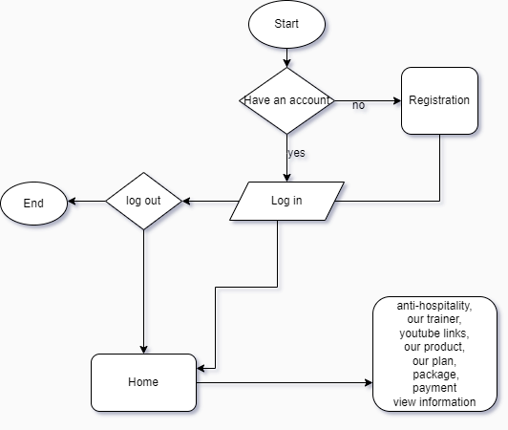

Figure 3.3.1: Flowchart

In this flowchart we tried to show the basic implementation of our website . First a user have to be logged in in order to get full feature access to our website . If he do not have an account then he can create an account by giving his email, username, password . Then he needs to log in by giving his email and password . If the given password and email matched with database data then he will be redirected to profile page . From that profile page he can go to other pages . He can go to main page . He can choose the options, he wants to membership . Then he can do registration for that package. Another feature is online product of exercise which will be available for buying . User can see trainer list and choose the trainer for him/her. User also take information about anti -hospitality which is taking without medicine.It give them physically and mentally refreshment. Here we give a list of trainer,anti-hospitality information, list of package to our user and user can choose for their fitness and healthy life . This feature is available after log in.

**3.4 Use Case Diagram**

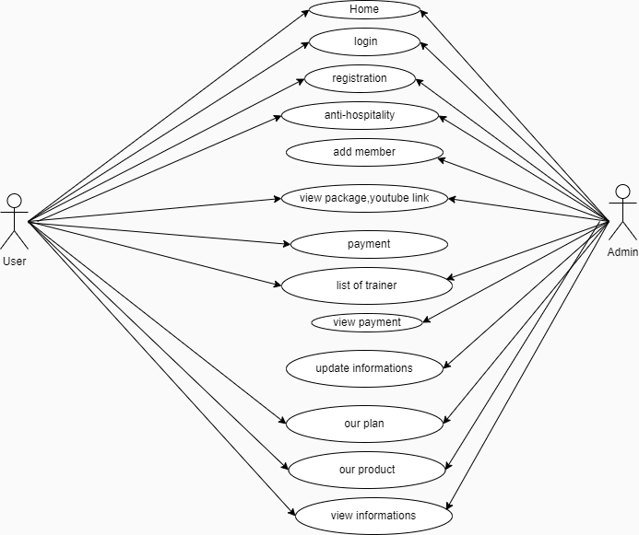

Figure 3.4.1: Use Case Diagram

You can already understand every details by seeing the diagram . Here a user first to see our homepage but he can not access any other except news feed from homepage . In order to get access for those pages he needs to have an account . If he have an account he can log in to that account if he don’t have an account then he needs to create an account . For creating account he need a picture which will later be his profile picture, a valid email address, an username, a strong password then confirm password.After creating account he can log in with his email and password . After log in he can access tournament , play game, game list option. Admin on the other hand will arrange these data .

**3.5 Entity Relationship Diagram**

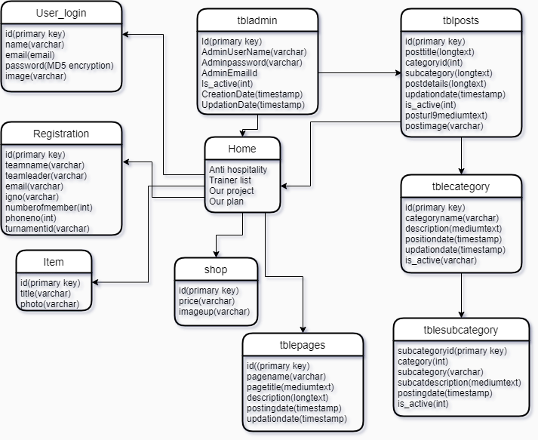

Figure 3.5.1: Entity Relationship Diagram

Here you can see that for each section we have created separated databases. For shop we have created a shopping database . For news feed we have created a new portal database . Here admin will upload news based on the category and subcategory . For account creating there is a database called user_login . Here we store user information that which is necessary for log in.

**3.6 Conclusion**

In this section we have discussed about our projects algorithm , draw a raw flowchart ,draw a use case diagram , draw an entity relationship diagram .We also explain major factors from each diagram , so that anyone can understand what is going on on those diagram.

**Chapter 4**

**Result Analysis & Discussion**

**4.1 Introduction**

So the implementation period is done . Now it’s time for us to introduce what every page of our website is capable of doing. I will go through each page , each functionality . Saying this again our project name is Green Life. It is a website where user can build their body shape, fitness and keep healthy without taking medicine. Our platform was build using HTML, CSS , JavaScript , PHP ,MySQL . Firstly we have spent our consider amount of time in learning this stuff . Then we began implementation. Learning and implementing at the same time was not easy task . That’s why it had taken more time to complete this project than we anticipated . We were given 13 weeks to complete the project but it had taken only 9 weeks to complete this project .Both me and my team member have given their all for this project .

There are some issue that we would like to discuss . It was actually very difficult for us develop a website .So we have to teach our selves first . First we learned HTML. You can say basics of HTML . Then we mode to CSS . We have learned the basic to intermediate level in both HTML and CSS . Then we start designing our web pages . Our first page was home page or you can say landing page .At this stage we didn’t need any PHP . Then we started to make our login , sign up page .For this we needed to learn PHP . How to connect to the database . How to retrieve data from database and how to insert data into database . After that we started adding code feature in our website . We added about our anti _hospitality and youtube links of our. Created a web page that will enable our user to visit out web application . Created a news feed section where user can find this web application.. We have enabled feature where user can edit their information which will change our database data .

Now let’s show the visual representation of our system. We will start form home page . Then explore through all the pages . We will also give some details information about each of these pages . So that it would be easier for reader’s to understand what is going on in pictures .We have taken multiple screen shoot . We would present these screen shoot along with description .

**4.2 Visual Representation of our System**

Below lies the visual representation of our entire system

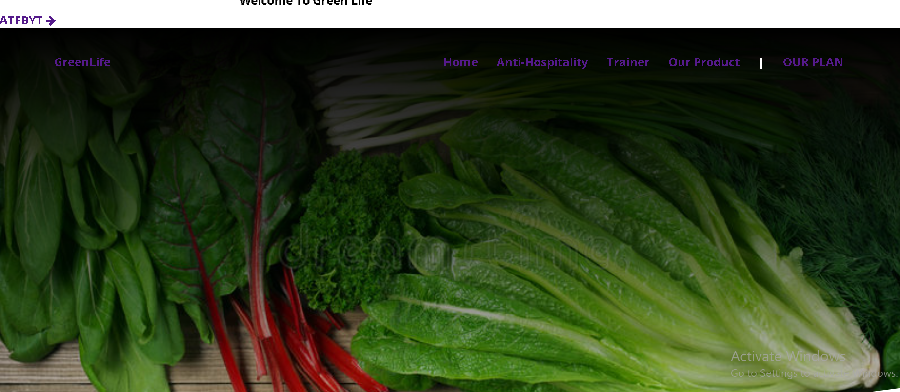

Figure 4.2.1: Home Page

This is our home page . The very first page user will face. Here we have shown features like anti_hospitality, information, our product , profile ,login . User can choose section with out being a member . If user wants to build up body or fitness without taking medicine, then user will have to log in . This page was developed using HTML, CSS, JavaScript , and PHP .

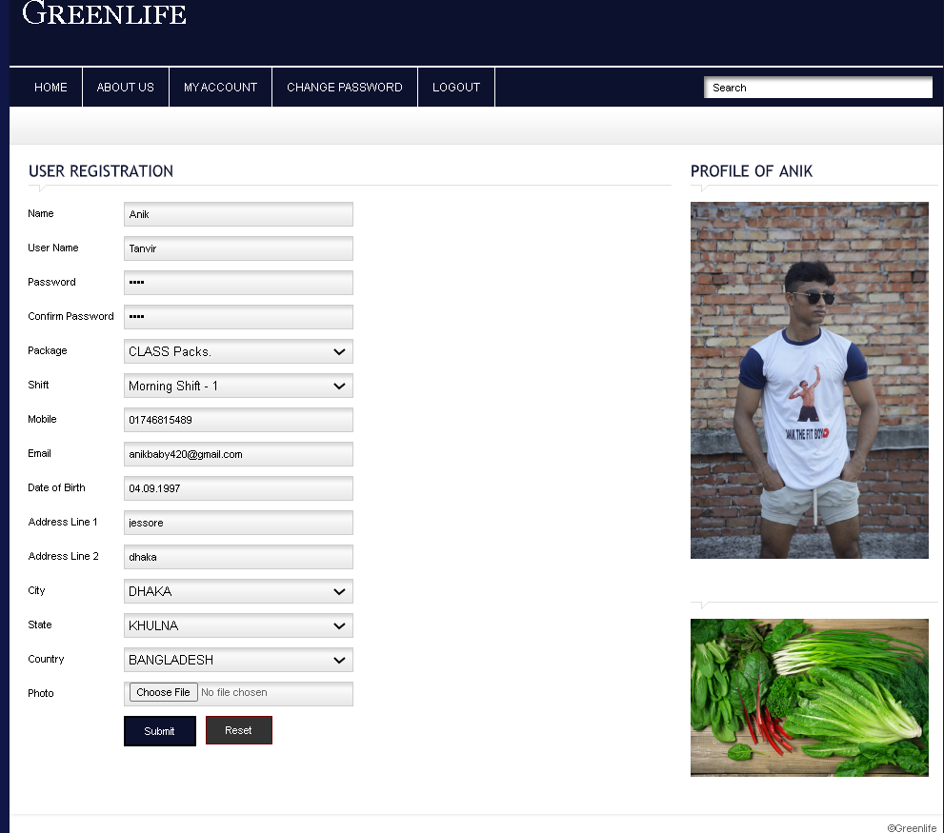

Figure 4.2.2: User Registration page

When user click on log in button he will be redirect to log in page . If he didn’t have any account then he can’t log in . So he needs to have an account . For this he needs to register with his required information . For a user to register he will have to give his username, email, password , Re type password , profile pic for his profile page . And there is a check in button for agreeing with out terms and condition . Password should match with retype password ,another wise it will create an error . After giving these information when he click on register now button his information will get store at login_db database . Here we will store password at MD5 hashing algorithm . This page was developed using HTML, CSS and PHP .



Figure 4.2.3: User profile page

This is our user profile page . From here user can access all the main feature of the app . Below profile page user will get notification whenever admin add a new game in game shop . User can also log out , update profile by clicking on the button. Update profile button will redirect to Update profile page . Log out button will logged you out and redirect you to login page .



Figure 4.2.4: Update profile page

This is the update profile page . From here user can update their information . The can update their username ,email address, can add new password , can update their profile picture . By clicking on update profile button he will be redirect to profile page with updated user information . Here user can remotely access database . Cause the data this page provide will update the data in login_db database.



Figure 4.2.5: Log in page

This is our log in page. In order to access the feature in the header section User needs to log in . Here user needs to give his email address and password which one he used to register . If the typed email address and password match with out database information then he will be recognize as a valid user . And he will be redirected to profile page. If he don’t have an account then he

needs to register . When he click register button he will be redirect to register page where he can register and create a new account . This page was developed using HTML, CSS and PHP .

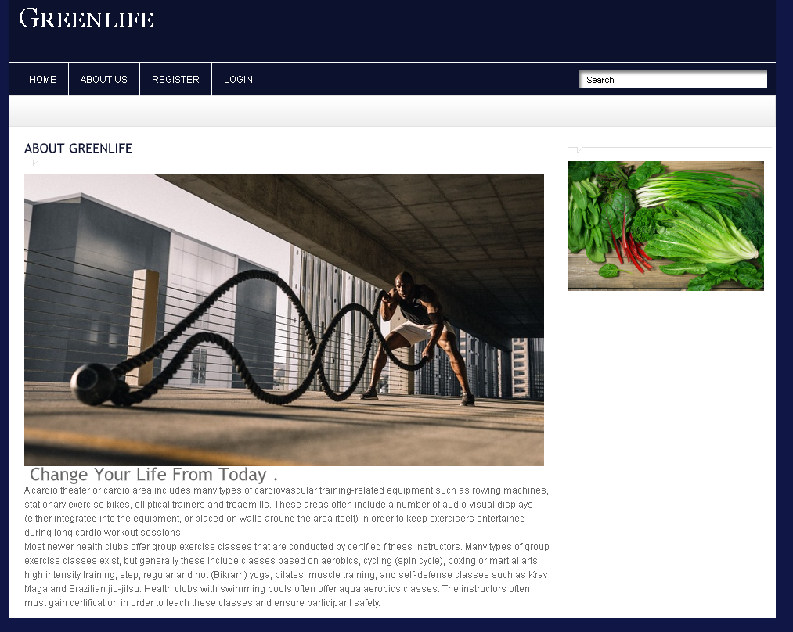

Figure 4.2.6: Condition page-1

Here is the condition page-1. In this page we have given our user a brief explanation of what we will do with the information we are storing about them .This page was developed using HTML, CSS .

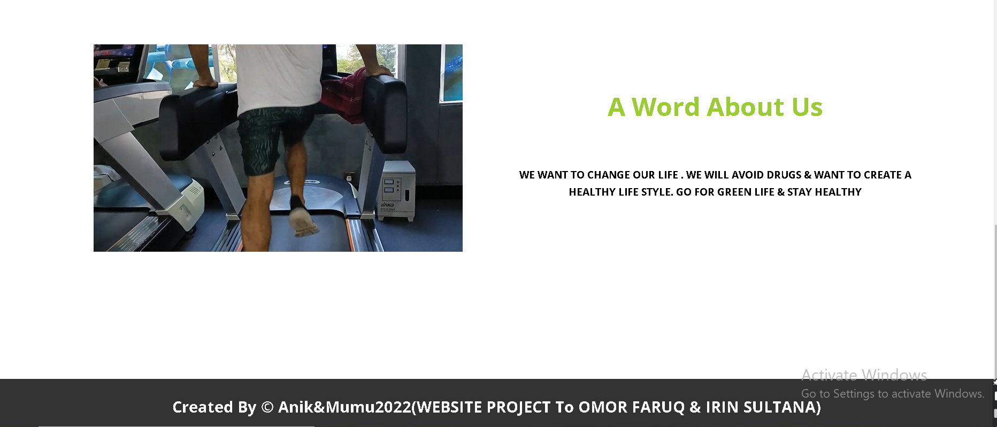

Figure 4.2.7:Condition page-2

Here is the condition page-2. Here we give our a word about us which is we want to change our life.We avoid drugs and want a happy life. In this page we have given our user a brief explanation of what we will do with the information we are storing about them .This page was developed using HTML, CSS .

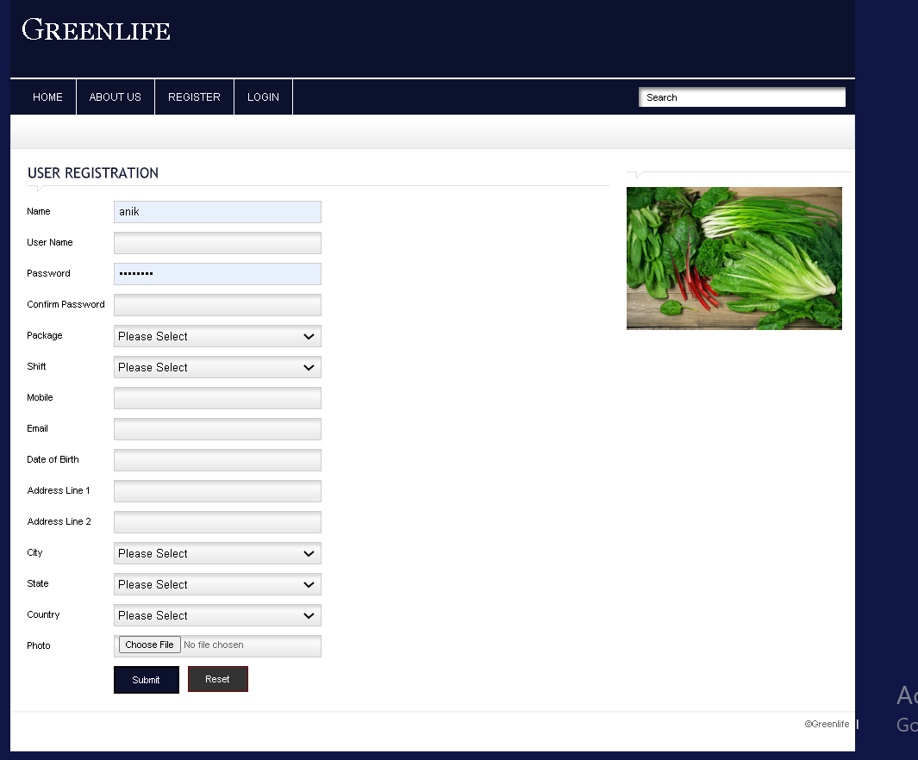

Figure 4.2.8: Privacy of users

In this website,one of our main priorities is the privacy of our visitors. This Privacy Policy document contains types of information that is collected and recorded and how we use it. If you have additional questions or require more information about our Privacy Policy, do not hesitate to contact us.This Privacy Policy applies only to our online activities and is valid for visitors to our website with regards to the information that they shared and/or collect in website links.This policy is not applicable to any information collected offline or via channels other than this website. Our Privacy Policy was created with the help of the Free Privacy Policy Generator.The personal information that you are asked to provide, and the reasons why you are asked to provide it, will be made clear to you at the point we ask you to provide your personal information.If you contact us directly, we may receive additional information about you such as your name, email address, phone number, the contents of the message and/or attachments you may send us, and any other information you may choose to provide.When you register for an Account, we may ask for your contact information, including items such as name, company name, address, email address, and telephone number.



Figure 4.2.9: Anti_ Hospitality Page

With internet connection user can easily see information of anti_hospitality ,yoga,about vegetable of diet chart and also product of yoga .This picture shows of item in our website . We have embedded code in our HTML code to make this work . It was quite easy .

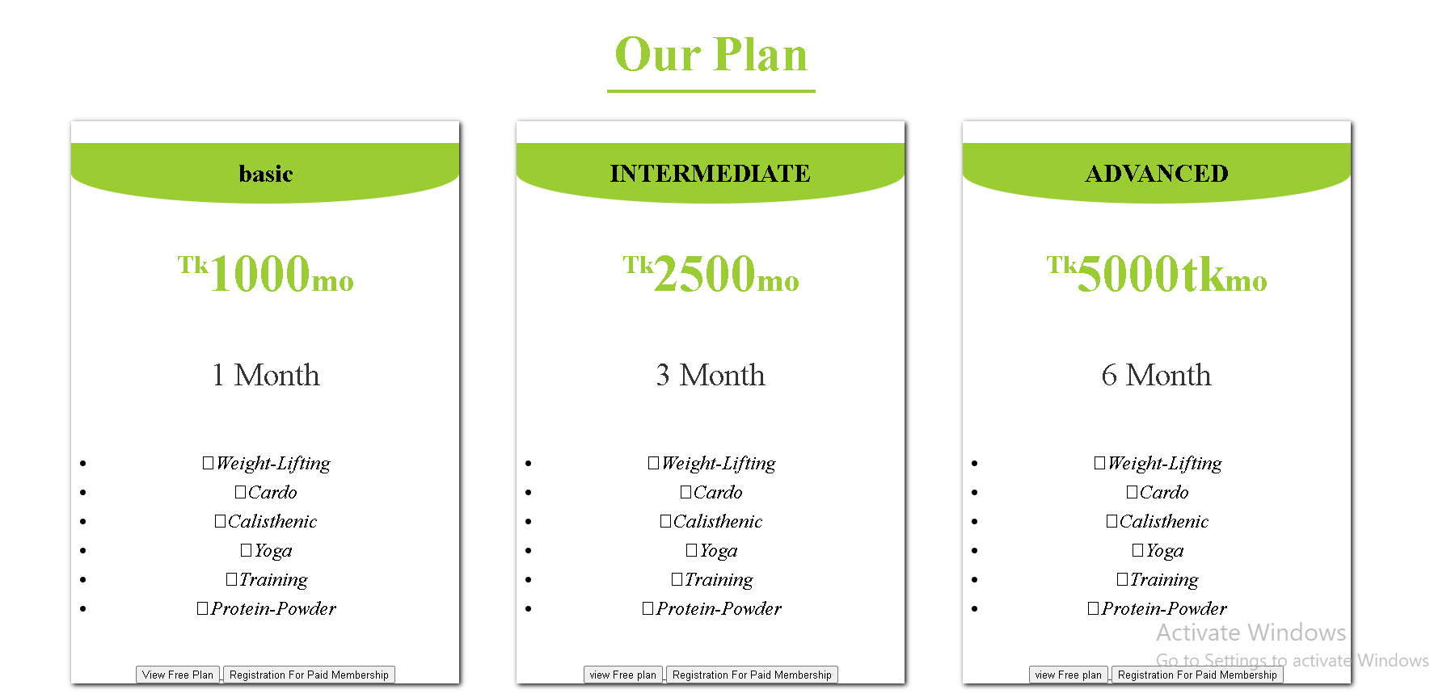

Figure 4.2.10: our plan

From this page user can see our plan after register and start choosing in our plan chart. As you can see we need some information regarding on this topic . our plan are basic, intermediate and advanced which are included for 1 month, 3 month and 6 month.these option are button enter the next pages. This plan is big crouse for user and big challenging crouse which is for weight lifting,weight gaining,weight losing, cardo, calisthenic ,yoga,training and protein powder.

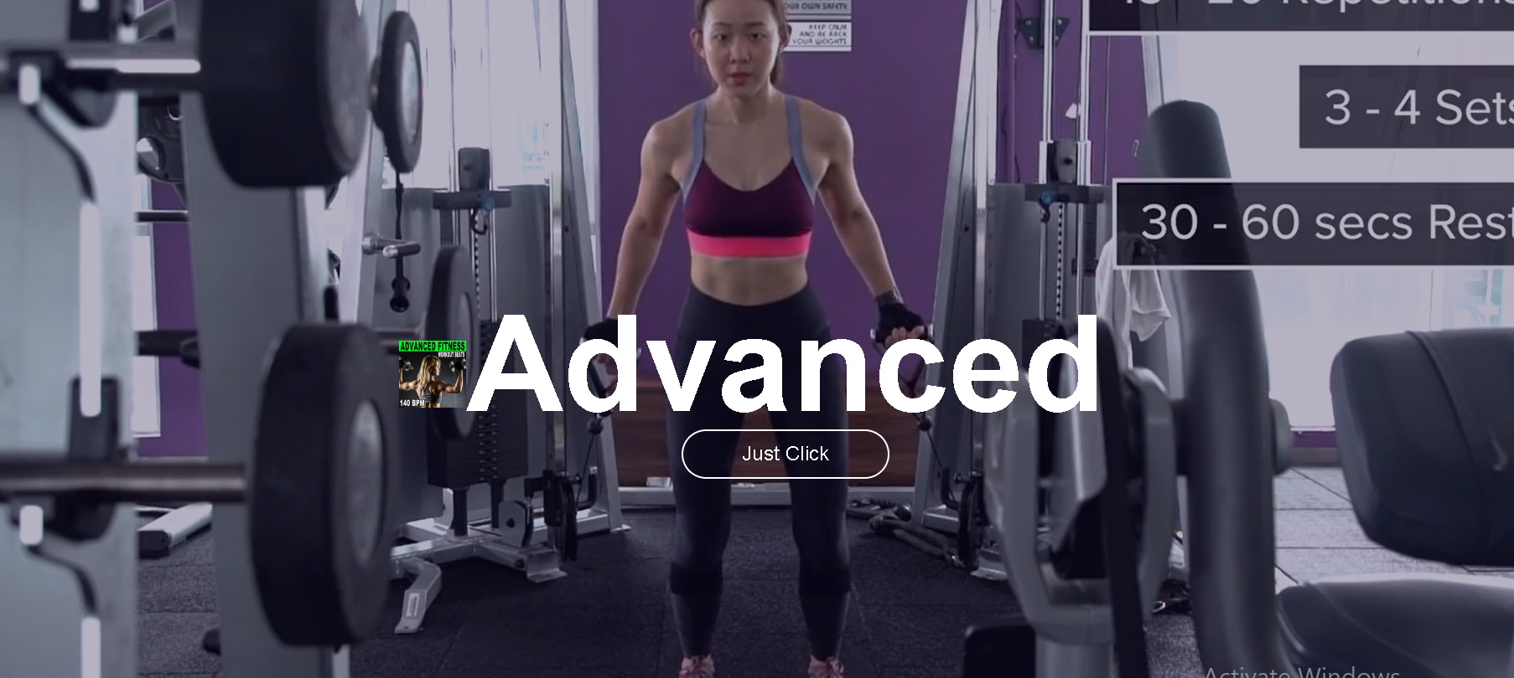

Figure 4.2.11: Advanced package

This plan is big crouse for user and big challenging crouse which is for 6 month and weight lifting,cardo, calisthenic ,yoga,training and protein powder.



Figure 4.2.12: About Page

This green Life which is consists of two members. Tanvir Ahmed ,Naima Mannan Mumu. Tanvir is an backend developer and database connection, me on the other hand wants to build by frontend developer.To complete this project both of us have given our all .

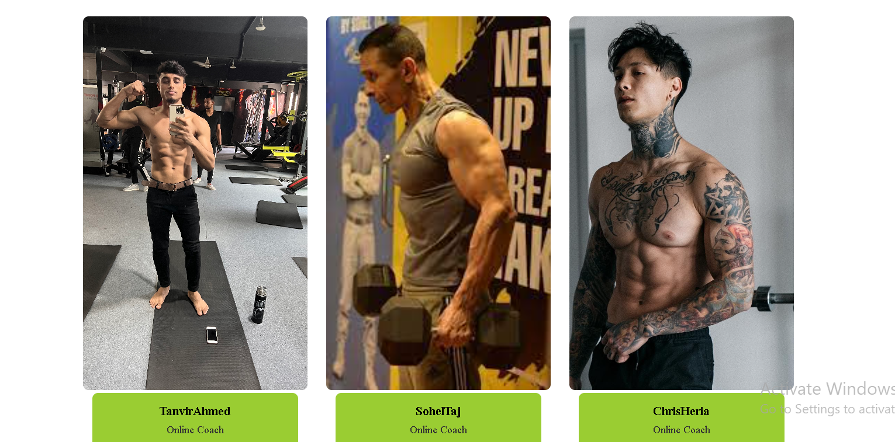

Figure 4.2.13: Our Trainer

This figure shows us the our trainer list with their profile pcture . In our website we will actually provide user with an form . That form will required all the needed information for an user to choose their trainer and will contain id,name,,email.

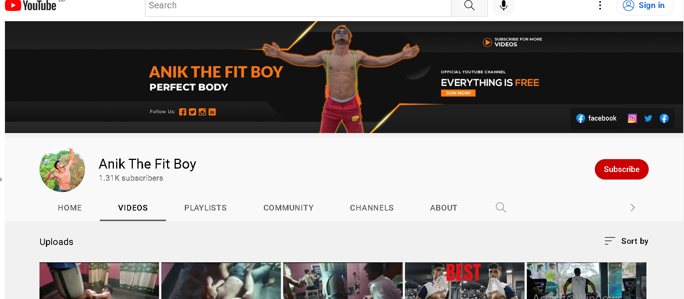

Figure 4.2.14: Youtube Channel

This figure shows us the youtube channel of ours. This channel has many links for user about our website. These videos are basic ,classic,weekly,monthly and crouse type. . All of these videos are used for different purposes . They store different kinds of information .



Figure 4.2.15: Log Out

This table contains the log out . It includes name,id mobile,email,address 1 and 2,city,state,country and photo. Number of members and how much prize the package .



Figure 4.2.16: Database Login Table

Figure 4.2.16 shows the login table. This table has id , name ,email,password, image attributes . Password will get store with MD5 hash encryption.

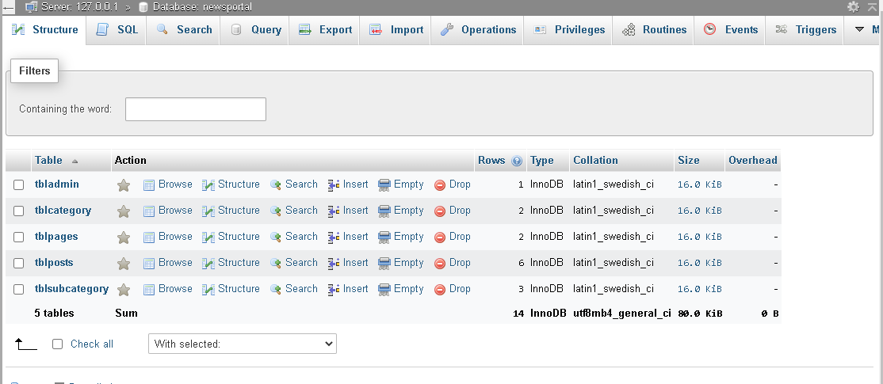

Figure 4.2.17: information Table

Figure 4.2.17 shows us the news portal database. This database has 5 tables. These tables are tbladmin ,tblcategory ,tblpages ,tblposts ,tblsubcategory . All of these tables are used for different purposes . They store different kinds of information .

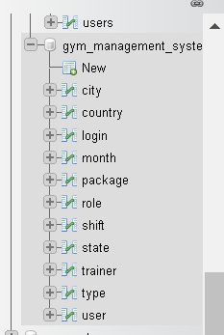

Figure 4.2.18: User Table

Figure 4.2.18 shows us the user table . This table contains the table file for our website . We give id,name and also other item of the website.

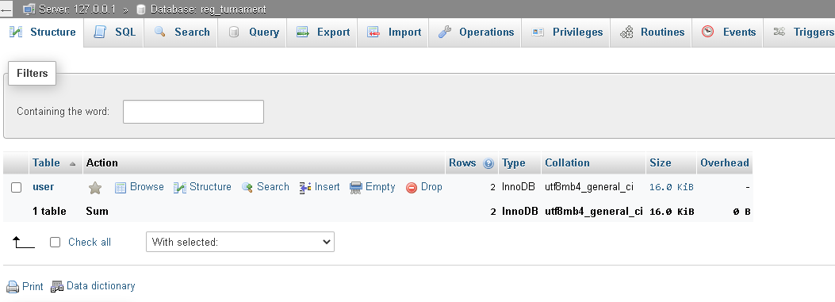

Figure 4.2.19: Register Table

Figure 4.2.19 shows us the register table . In our website we will actually provide user with an form . That form will required all the needed information for an user to choose will contain id,name,,email, list of trainer id.

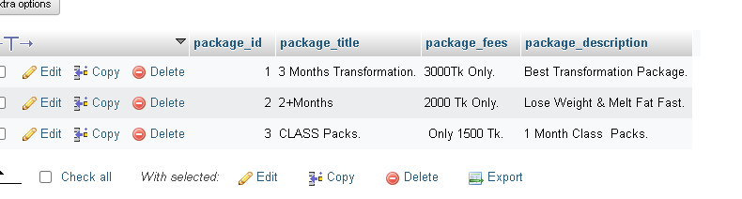

Figure 4.2.20: package Table

Figure 4.2.20 shows us the package table. We created this table in order to upload 3 month transformation,2plus month andclass packs which is included by package fees in our website . This table contain information about package name, package fees and an image for the package.

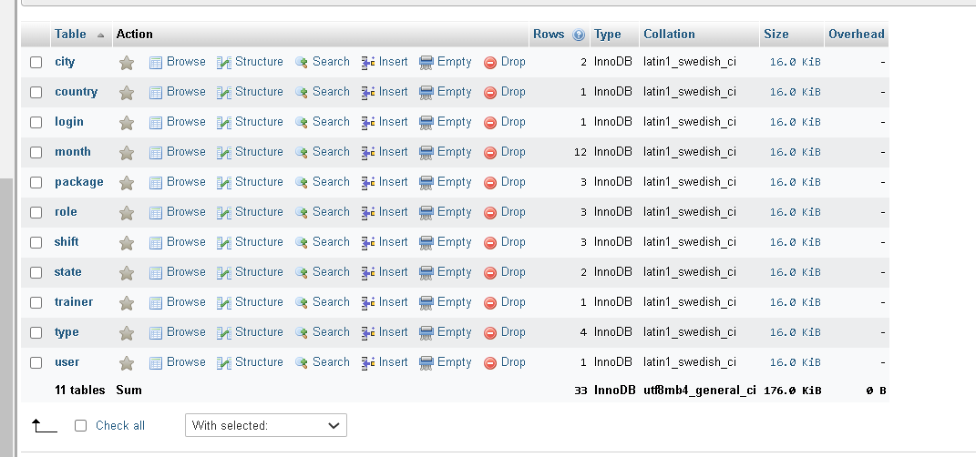

Figure 4.2.21: Upload Table

Figure 4.2.21 shows us the upload table . In order to create a profile, we need to upload information in our website . W will upload title, tournament id, photo and a describe page for the green life activities .

**4.3 Discussion**

It took large amount of work time to design those pages . As you can see there are approximately 43 figures up there . And there are approximately more than 30 web pages . Designing these 30 web pages was not an easy task . We have tried our best . Still there is much room for improvements .We have actually learn many thing while doing this project . That was one of our idea to work on a big project , cause it will help us learn many new things . It will improve our ability to work under pressure .

**4.4 Conclusion**

Doing a project is the only way to sharp your skills . It also help us develop new one . Green Life is an web application . We have used HTML, CSS, PHP , JavaScript . From start we were not very familiar with these skills , but we did learn on the way .

**Chapter 5**

**Conclusion & Future Work**

**5.1 Introduction**

So the implementation period is done . Now it’s time for us to introduce what every page of our website is capable of doing. I will go through each page , each functionality . Saying this again our project name is Green Life . It is a website where user can keep their body perfectly with healthy ,shapely by doing yoga or maintance the rules of our web site. Here we want to change our life. We will avoid drugs and want to create a healthy life style. Our platform was build using HTML, CSS , JavaScript , PHP ,MySQL . Firstly we have spent our consider amount of time in learning this stuff . Both me and my team member have given their all for this project .

**5.2 Future Work**

Our project has much scope of improvements . After completing the proposed feature we were attempting to add another feature . We were trying to add live streaming feature .By adding this feature user will be able to stream when they choose the package or see the our link of videos . It will connect with OBS Studio . Our website will provide a stream key . User can connect with OBS Studio with this stream key . For this to work we need rtmp server . RTMP is real time messaging protocol . We will user docker container to host rtmp server . For Docker container to work publicly we need a ubuntu os with public IP .

**5.3 Conclusion**

Our project is Green Life, it is a website that provides latest information of anti _hospitality ,yoga and exercise . It also arranged our product for helping to do yoga or exercise and there is a store to buy product . Though there are some existing platform for this for a long time but we wanted to do something innovative . Like we wanted to arrange all of the feature other website provide and packed them together .It’s always a great practice to sharp our skills . And doing a project is the best way to do it . It also help us develop new one . Green Life is an web application . We have used HTML, CSS, PHP , JavaScript . From start we were not very familiar with these skills , but we did learn on the way .

**REFERENCES**

[1]https://www.medicalnewstoday.com/articles/the-stolen-cells-of-henrietta-lacks-and-their-ongoing-contribution-to-science

[2]<https://www.medicalnewstoday.com/articles/cardio-exercises-at-home>

[3][https://www.hindustantimes.com/lifestyle/health/shilpa-shetty-is-off-to-a-happy-start-with-yoga-exercises-and-we-are-inspired-101648451901157. html](https://www.hindustantimes.com/lifestyle/health/shilpa-shetty-is-off-to-a-happy-start-with-yoga-exercises-and-we-are-inspired-101648451901157.%20html)

[4] [https://en.wikipedia.org/wiki/Olympic_weightlifting](https://l.messenger.com/l.php?u=https%3A%2F%2Fen.wikipedia.org%2Fwiki%2FOlympic_weightlifting&h=AT1CU97VsWBuWcAFgxRwElHt3lsmBB0y3rTkvjVEQQrL99BI1IPwaCP1CRjkX2xr8skOd6x1YhJaff3wCErf8cKAVEWPTgOKiqRv4Ji3_xxV2Y7P8xjZfKJNaDklpeXA_bQL8g) .

[5]<https://www.medicalnewstoday.com/articles/cardio-exercises-at-home>.

[6] [Thenx](https://thenx.com/).com.

[7][What is it like to donate stem cells? (medicalnewstoday.com)](https://www.medicalnewstoday.com/articles/through-my-eyes-stem-cell-donation)

[8][Protein for muscle mass: What is the optimal intake? (medicalnewstoday.com)](https://www.medicalnewstoday.com/articles/how-much-protein-do-you-need-to-build-muscle)

[9][In Conversation: The experience of and science behind chronic pain (medicalnewstoday.com)](https://www.medicalnewstoday.com/articles/in-conversation-how-to-understand-chronic-pain)